**Output Of Entire Table**

select * from Products;

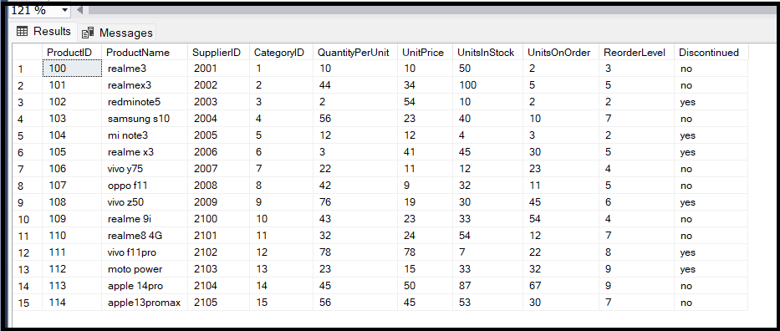

**Output Of Query1**

**Query1:** Write a query to get a Product list (id, name, unit price) where current products cost less than $20.

select ProductID,ProductName,UnitPrice from Products where UnitPrice<20;

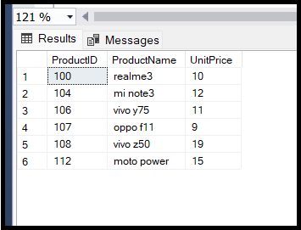

**Output Of Query2**

**Query2:** Write a query to get Product list (id, name, unit price) where products cost between $15 and $25

select ProductID,ProductName,UnitPrice from Products where UnitPrice between 15 and 25;

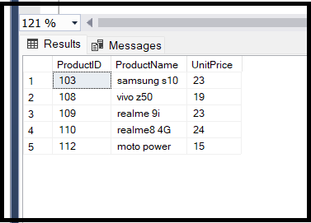

**Output Of Query3**

**Query3:** Write a query to get Product list (name, unit price) of above average price.

select ProductName,UnitPrice from Products where Unitprice>(select AVG(UnitPrice) from Products);

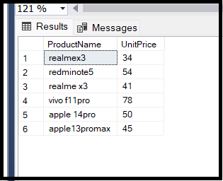

**Output Of Query4**

**Query4:** Write a query to get Product list (name, unit price) of ten most expensive products

select top 10 ProductName,UnitPrice from Products order by UnitPrice desc;

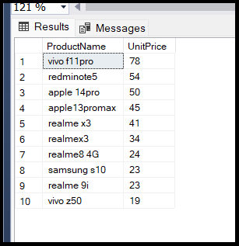

**Output Of Query5**

**Query5:** Write a query to count current and discontinued products

select Discontinued, count(CategoryID) as no_of_products

from Products

group by Discontinued

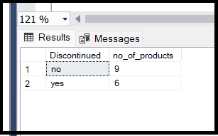

**Output Of Query6**

**Query6:** Write a query to get Product list (name, units on order , units in stock) of stock is less than the quantity on order

select ProductName,UnitsOnOrder,UnitsInStock

from Products

where UnitsInStock < UnitsOnOrder

